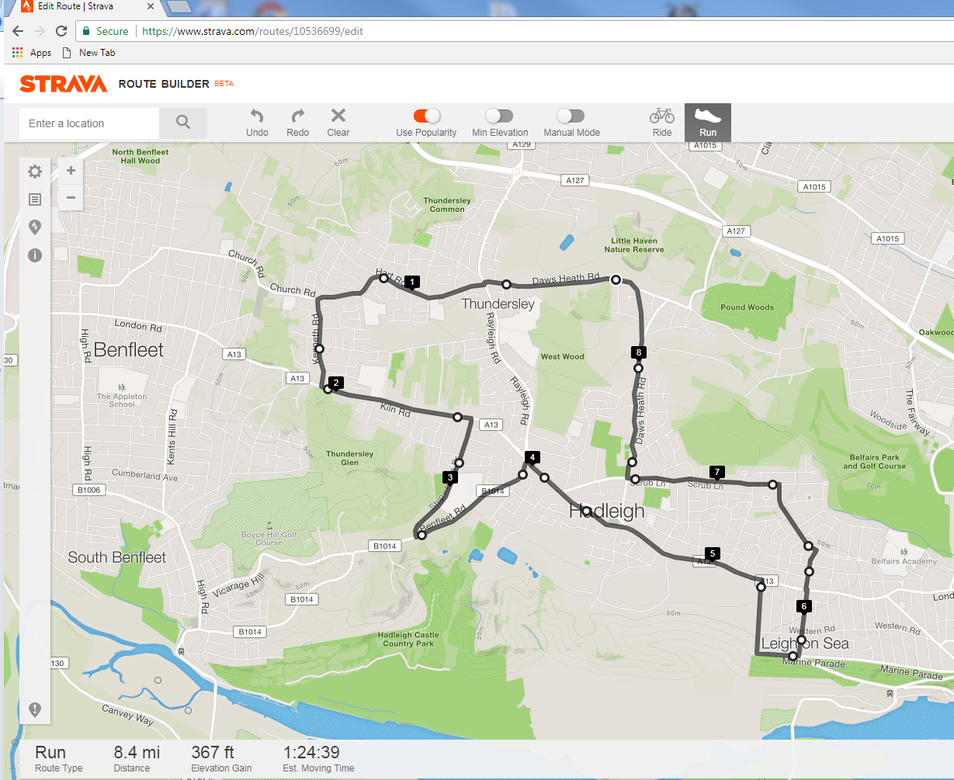

***Havens Marathon Team – 8.4 Mile Route***

[***https://www.strava.com/routes/10536699***](https://www.strava.com/routes/10536699)

Brief Route Description:

Start - Top of Little Havens Drive

Follow route out to Vic House Roundabout (4.0 miles)

Run through Hadleigh One-Way System

 - TR into Tattersall Gardens (5.2 miles)

 - TL @ Traffic Lights into Thames Drive (5.7 miles)

Cross A13 into Sutherland Blvd – TL into Highlands Blvd

TL into Scrub Lane (6.7 miles)

Follow route back to Little Havens (8.4 miles)