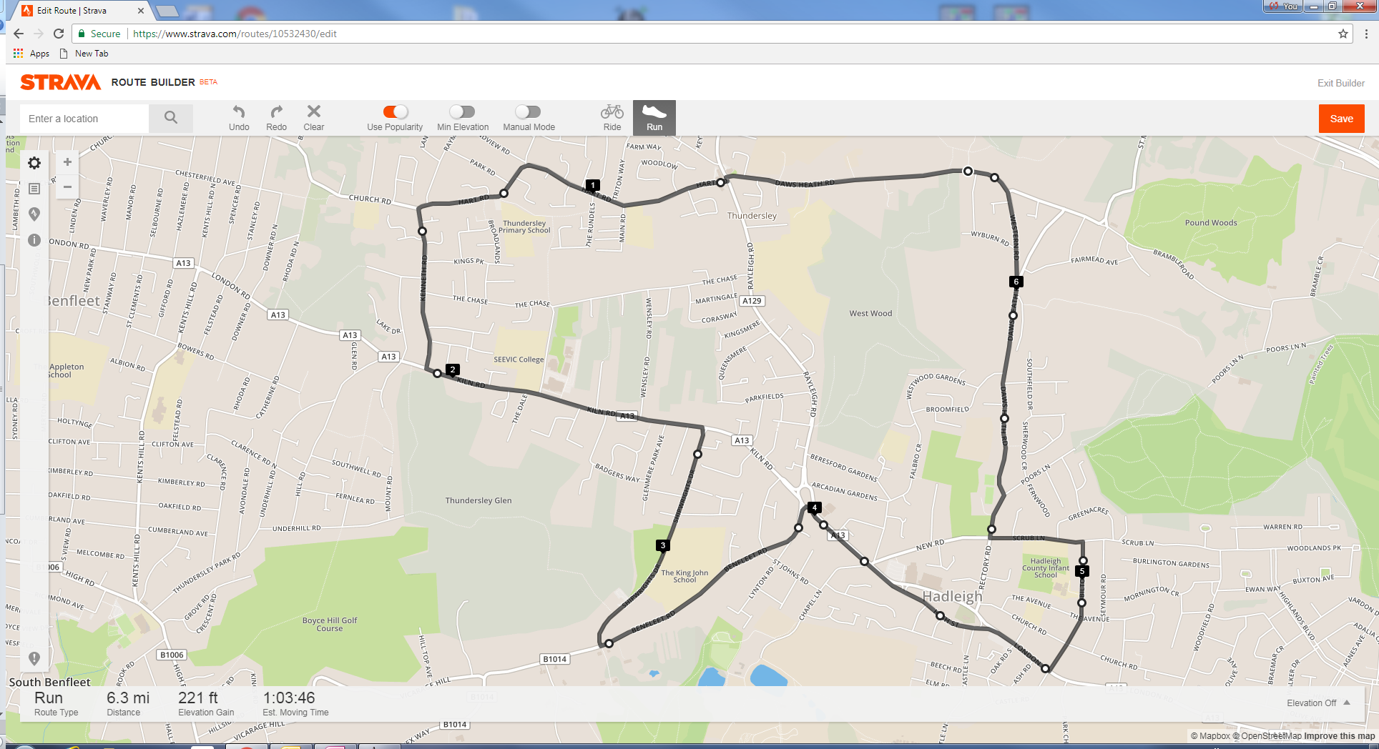

***Havens Marathon Team – 6.3 Mile Route***

[***https://www.strava.com/routes/10532430***](https://www.strava.com/routes/10532430)

Brief Route Description:

Start - Top of Little Havens Drive

Follow route out to Vic House Roundabout (4.0 miles)

Run through Hadleigh one-way system

 - TL into Meadow Road (4.7 miles)

 - TL into Scrub Lane (5.1 miles)

Follow route back to Little Havens (6.3 miles)