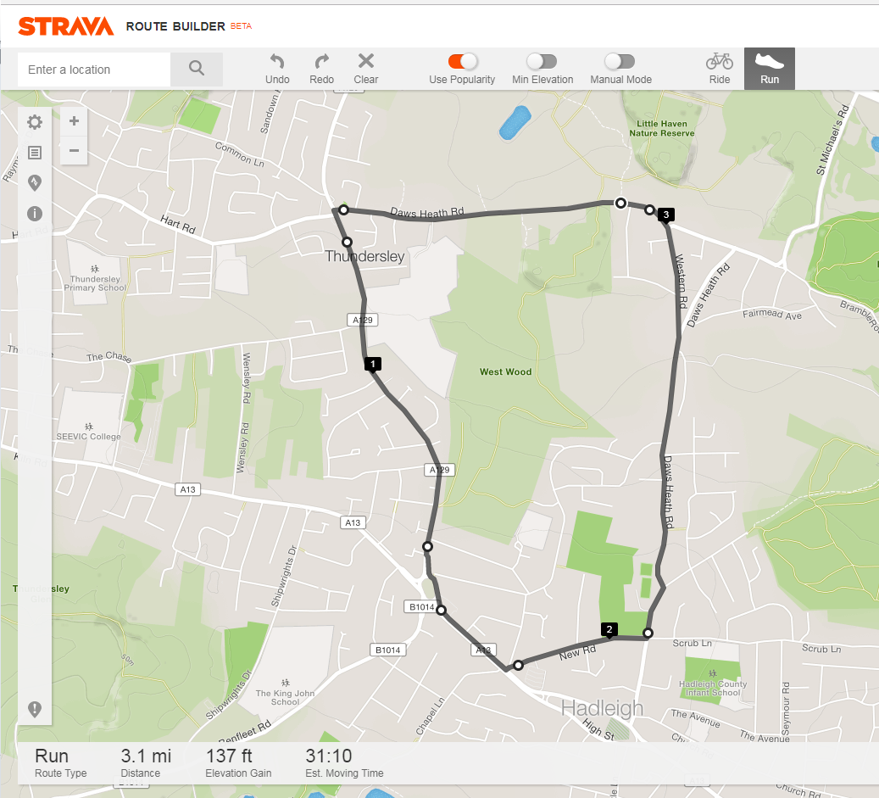

***Havens Marathon Team – 3.1 Mile Route***

***https://www.strava.com/routes/10657945***

Route Description:

Start - Top of Little Havens Drive

TR Follow Road to Woodman’s mini Roundabout (0.6 miles)

TL onto A129

Bare L @ Vic House Roundabout onto A13 (1.4 miles)

Cross Road @ Chapel Lane Lights (1.7 miles)

Bare R into New Road

TL @ Lights into Daws Heath Road (2.1 miles)

Run back to Little Havens (3.1 miles)