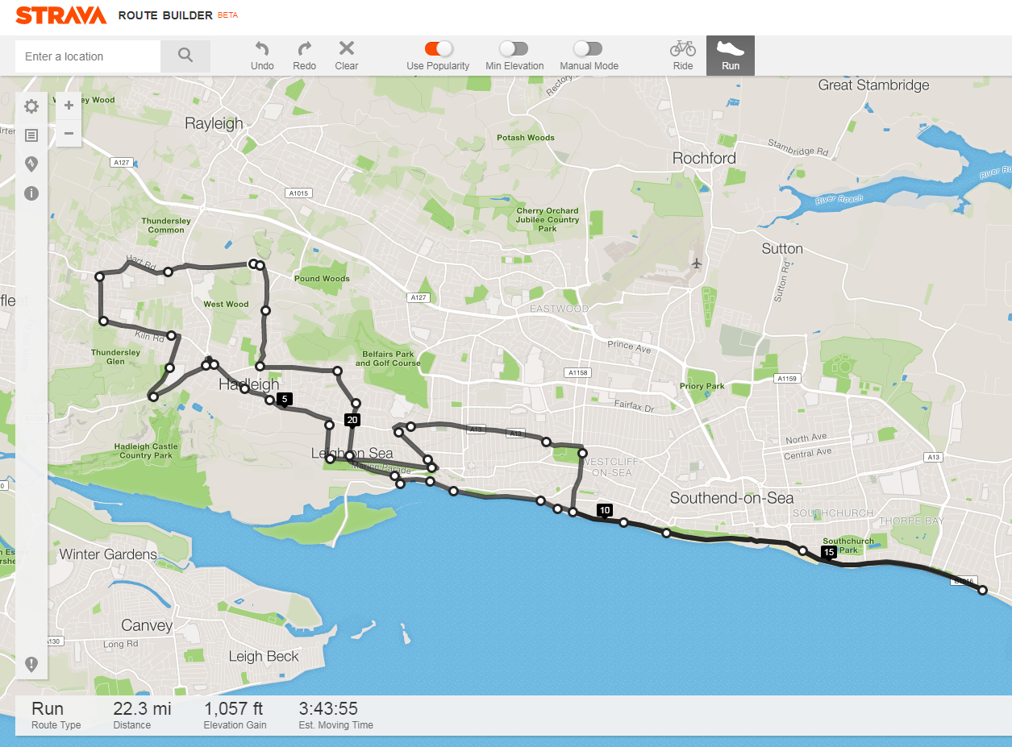

***Havens Marathon Team – 22.3 Mile Route***

***https://www.strava.com/routes/10537555***

Brief Route Description:

Start - Top of Little Havens Drive

Follow route out to Vic House Roundabout (4.0 miles)

TR into Tattersall Gardens (5.2 miles)

Run along Marine Parade

TL into Hadleigh Road to A13 (6.6 miles)

- TL onto Seafront (9.7 miles)



 - Turn Around Point – Thorpe Bay Yacht Club (13.5 miles)

Run through Old Leigh To Leigh Station (19.2 miles)

Up Belton Way / Thames Drive

Follow route back to Little Havens (22.3 miles)