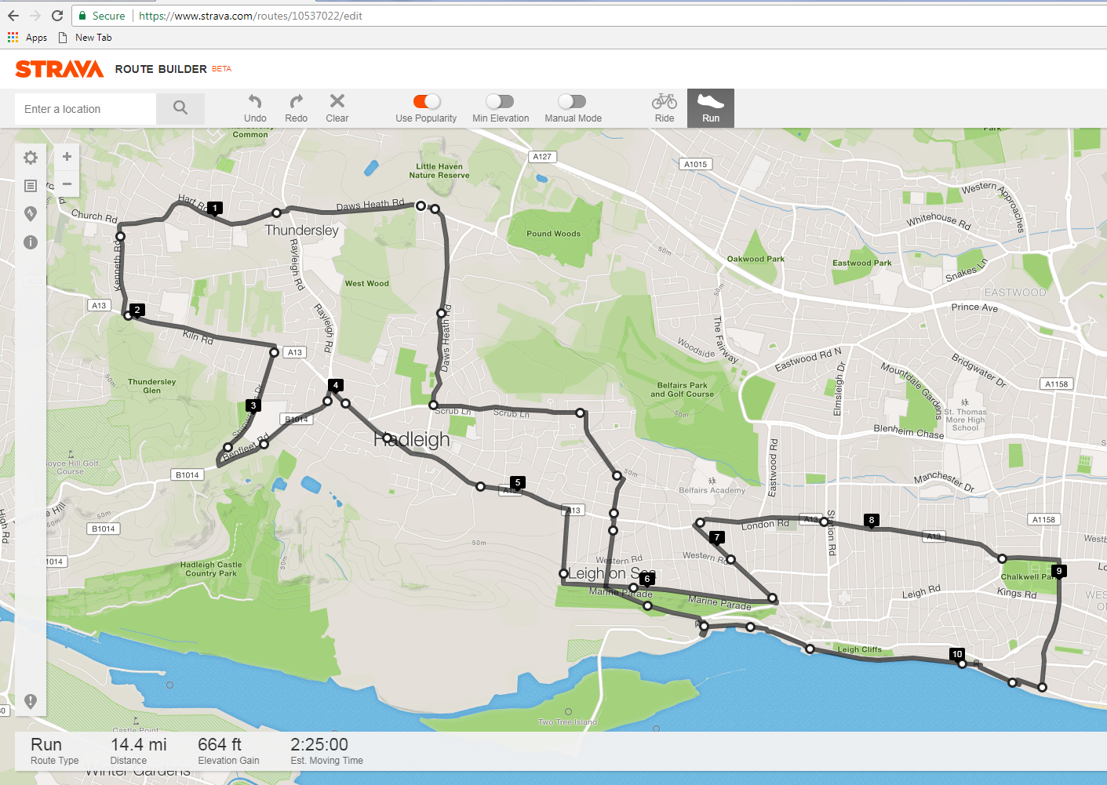

***Havens Marathon Team – 14.4 Mile Route***

***https://www.strava.com/routes/10537022***

Brief Route Description:

Start - Top of Little Havens Drive

Follow route out to Vic House Roundabout (4.0miles)

Run through Hadleigh One-Way System

Run along Marine Parade

- TL into Hadleigh Road towards A13 (6.9miles)



- TR into Chalkwell Av – To Seafront (8.9miles)



Run through Old Leigh to Leigh Station (11.3miles)

Up Belton Way – Thames Drive

Follow route back to Little Havens (14.4miles)

|  |  |  |  |  |  |  |  |
| --- | --- | --- | --- | --- | --- | --- | --- |
|  |  | | |  |  | | |
|  | |  | **Havens Marathon Team - 14.4 Mile Route** | | | **8.9** | Run down Chalkwell Ave to Seafront | |
|  | |  |  | | | **9.5** | TR into Seafront Car Park | |
|  | |  | https://www.strava.com/routes/10537022 | | |  | Join Seafront path SO towards Leigh | |
|  | |  |  | | | **10.3** | SO past Spiral Footpath | |
|  | |  | **R - R**ight **L - L**eft **X - C**ross **SO - S**traight **O**n | | | **10.35** | SO past Mine Sweeper | |
|  | |  | **TR - T**urn **R**ight **TL - T**urn **L**eft | | | **10.6** | SO Thro' Old Leigh High St | |
|  | | (Miles) | Top of Little Havens Drive - **TR** into Daws Heath Road | | | **10.9** | SO under bridge past carpark on road next to Railway | |
|  | | **Start** | Woodman's Pub - SO into Hart Road (Use Crossing) | | | **11** | SO past Cockle Sheds | |
|  | | **0.6** | Bare **L** Past Thundersley shops | | | **11.2** | Run round Hair Pin Bend - TR to cross Railway Bridge | |
|  | | **1.1** | **TL** @ Mini Roundabout into Kenneth Road | | | **11.3** | Run past Station **TL** onto Belton Way West | |
|  | | **1.5** | Run to end of road - **TL** into Kiln Road (A13) | | |  | Run uphill to Traffic Lights with Marine Parade | |
|  | | **1.9** | **X** onto **RH** side of Road @ Crossing | | | **11.8** | **SO** at Traffic Lights onto Thames Drive | |
|  | |  | Turn **R** into Shipwrights Drive | | | **12.1** | **SO** at Traffic Lights crossing A13 into Sutherland Blvd | |
|  | | **2.7** | Run to end of road - **TL** into Benfleet Road | | | **12.3** | **TL** into Highlands Blvd - Run to end of road | |
|  | | **3.3** | Follow Benfleet Road to Vic House Roundabout | | | **12.7** | **TL** into Scrub Lane - Run to end of road | |
|  | |  | Use crossing Just before Vic House Roundabout | | | **13.4** | At Traffic Lights **TR** into Daws Heath Road | |
|  | | **3.9** | Continue to Roundabout - **TR** into London Road (A13) | | | **13.9** | **SO** Past Mini Roundabout | |
|  | |  | **SO** thro' Hadleigh One Way System | | |  | **SO** Uphill | |
|  | | **4.3** | **SO** along A13 | | | **14.4** | Follow road round to **L** - Finish at Little Havens Entry Gate | |
|  | | **4.5** | **TR** into Tattersall Gardens - Run downhill to end of road | | |  |  | |
|  | | **5.2** | **TL** into Marine Parade | | |  |  | |
|  | | **5.5** | **SO** at Traffic Lights along Marine Parade to end | | |  |  | |
|  | | **5.7** | **TL** onto Hadleigh Road - Run to End of Road | | |  |  | |
|  | | **6.6** | TR onto London Road (A13) | | |  |  | |
|  | | **7.1** | Follow A13 To Chalkwell Park | | |  |  | |
|  | | **8.6** | Far end of Park - TR into Chalkwell Av | | |  |  | |