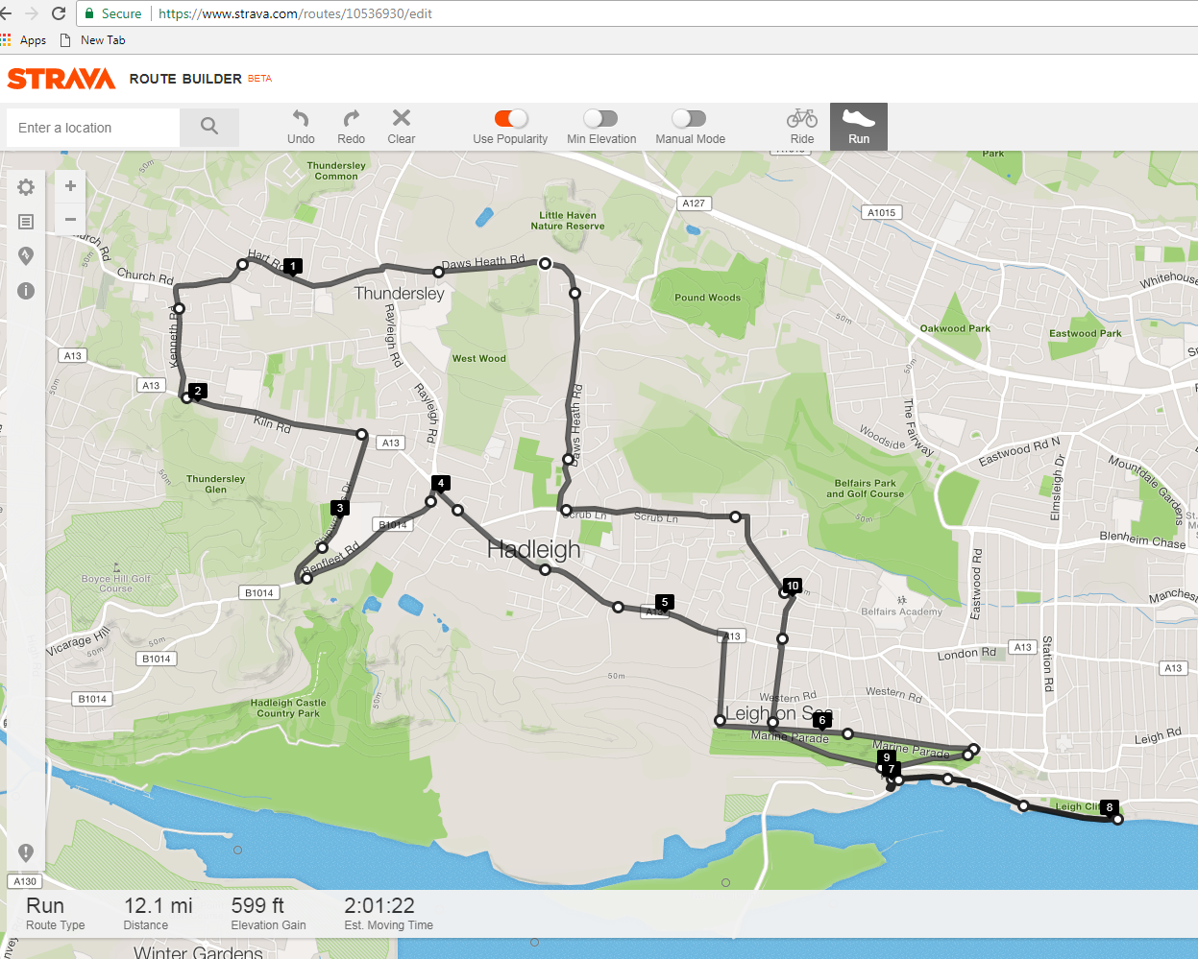

Brief Route Description:

Start - Top of Little Havens Drive

Follow route out to Vic House Roundabout (4.0 miles)

Run through Hadleigh One-Way System

Run along Marine Parade – Down Belton Way East

- TL @ Station – Cross Railway Bridge (6.9 miles)



 - Touch Spiral Footbridge – Retrace Steps (7.9 miles)

Cross A13 into Sutherland Blvd – TL into Highlands Blvd

TL into Scrub Lane (10.3 miles)

Follow route back to Little Havens (12.1 miles)

***Havens Marathon Team – 12.1 Mile Route***

***https://www.strava.com/routes/10536930***

|  |  |  |  |  |  |
| --- | --- | --- | --- | --- | --- |
|  |  |  |  |  |  |
|  |  | **Havens Marathon Team - 12.1 Mile Route** |  | Bare **L** following road next to railway line |  |
|  |  | https://www.strava.com/routes/10536930 | **7.2** | **SO** past Cockle Sheds |  |
|  |  |  | **7.4** | **SO** into Old Leigh High St - Crooked Billet Pub on **L** |  |
|  |  | **R - R**ight **L - L**eft **X - C**ross **SO - S**traight **O**n | **7.6** | **SO** past cobbles to narrow path next to railway |  |
|  |  | **TR - T**urn **R**ight **TL - T**urn **L**eft | **7.8** | **SO** Past Mine Sweeper |  |
|  | ( Miles ) |  | **7.9** | Touch Spiral Footbridge - Turn round Point 12,1 Mile |  |
|  | **Start** | Top of Little Havens Drive - **TR** into Daws Heath Road |  | Retrace Route Past - Mine Sweeper - Old Leigh High St |  |
|  | **0.6** | Woodman's Pub - **SO** into Hart Road ( Use Crossing ) |  | Retrace Route Past - Cockle Sheds to Railway Bridge |  |
|  | **1.1** | Bare **L** Past Thundersley shops | **8.9** | Run past Station **TL** onto Belton Way West |  |
|  | **1.5** | **TL** @ Mini Roundabout into Kenneth Road |  | Run uphill to Traffic Lights with Marine Parade |  |
|  | **1.9** | Run to end of road - **TL** into Kiln Road (A13) | **9.4** | **SO** at Traffic Lights onto Thames Drive |  |
|  |  | **X** onto **RH** side of Road @ Crossing | **9.7** | **SO** at Traffic Lights crossing A13 into Sutherland Blvd |  |
|  | **2.7** | Turn **R** into Shipwrights Drive | **9.9** | **TL** into Highlands Blvd - Run to end of road |  |
|  | **3.3** | Run to end of road - **TL** into Benfleet Road | **10.3** | **TL** into Scrub Lane - Run to end of road |  |
|  |  | Follow Benfleet Road to Vic House Roundabout | **11.1** | At Traffic Lights **TR** into Daws Heath Road |  |
|  | **3.9** | Use crossing Just before Vic House Roundabout | **11.5** | **SO** Past Mini Roundabout |  |
|  |  | Continue to Roundabout - **TR** into London Road (A13) |  | **SO** Uphill |  |
|  | **4.3** | **SO** thro' Hadleigh One Way System | **12.1** | Follow road round to **L** - Finish at Little Havens Entry Gate |  |
|  | **4.5** | **SO** along A13 |  |  |  |
|  | **5.2** | **TR** into Tattersall Gardens - Run downhill to end of road |  |  |  |
|  | **5.5** | **TL** into Marine Parade |  |  |  |
|  | **5.7** | **SO** at Traffic Lights along Marine Parade |  |  |  |
|  | **6.6** | **TR** onto Belton Way East - Run Downhill to Station |  |  |  |
|  | **6.9** | Leigh Railway Station - **TL** Cross Over Railway Bridge |  |  |  |
|  | **7** | **TL** following Hair Pin Bend |  |  |  |

***Havens Marathon Team – 12.1 Mile Route***

***https://www.strava.com/routes/10536930***